You have 50 minutes (one class period) to complete this exam. Your answers must be recorded on this exam. This is a closed book, closed notes, (and closed neighbor) exam. You may ask the instructor questions but do not disturb your classmates. The Radford University Honor Code will be strictly enforced!

Questions 1-30 are short answer, fill in the blank, true/false and multiple choice. Each questions is worth 2 points.

- The first step in the waterfall model of software development is ___________________.

- A ________________________ defines a process to be followed during development of a system.

- The ________________ Development Model generally results in code that is less structured and more difficult to maintain.

- The _________ model of software development is designed to reduce risk.

- The two principle risks in software development are _______________________ and _________________________.

Questions 6 - 9 relate to the following UML diagram.
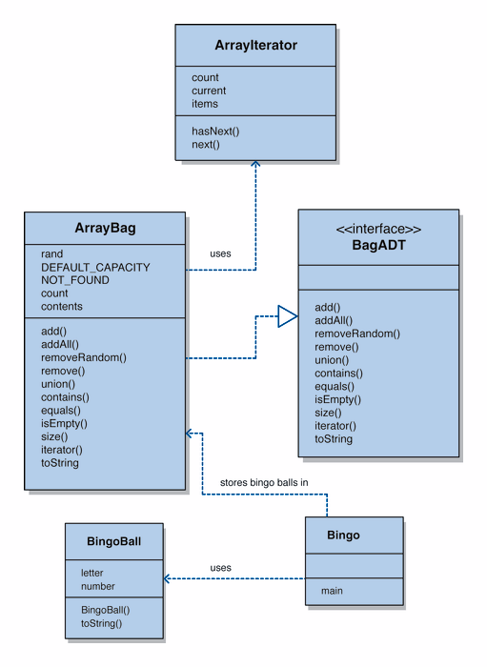

- BagADT is a ______________.

- Bingo and BingoBall are _______________.

- The relationship between ArrayBag and BagADT is an example of ____________.
  - Implementation
  - Aggregation
  - Inheritance
  - None of the above

- The relationship between ArrayBag and ArrayIterator is an example of ____________.
  - Implementation
  - Aggregation
  - Inheritance
  - None of the above

- True or False, Bingo implements BingoBall.

- True or False, the non-recursive part of a recursive definition is called the base case and is required.

- Recursion that does not terminate is called ___________________.

- If method A calls B, B calls C, and C calls A, this is called ____________________.

- A ____________ is an object that collects and organizes other objects.

- A ____________ is a Java concept that allows the developer to design how a class can be used without specifying the implementation where as a _____________ will implement some but not all of the methods.

- A _____________ is a data type that is not inherently defined in the language.

- A ______________ is an object that allows us to step through the elements of a collection one at a time from outside the collection.

- List three ways to deal with a possible exceptional situation.

- In inserting a node in the front of a linked list, the order of operations is crucial. Given that front points to the first node in the list and that element points to the element to be inserted, which of the following is the correct sequence of operations.
A. front.next = element
element.next = front

B. element.next = front.next
front.next = element

- element.next = front
front = element

- A linked list is dynamic meaning that it _______________________________________ while array structures are static meaning they have ___________________.

- How can Bubble Sort be made to be more efficient?

- _____________ is the process of either finding a designated target within a list of items or determining that it does not exist.

- The process of searching by comparing to the middle element of a sorted list and then repeating that process recursively, dividing the list in half each time, until the target is found or the list is exhausted is called _______________.

- _____________ Sort sorts a list of values by repetitively inserting a particular value into a subset of the list that has already been sorted.

- Selection Sort is O(______) while Merge Sort is O(_______).

- _____________ Sort sorts a list of values by partitioning the list using an arbitrarily chosen partition element and then recursively sorting the sub-lists on either side of the partition element.

- The graph represents four growth functions (n log n, n², n, 2^{n}). Place each label on the appropriate curve on the graph.

- The following code segment is O(____).

for (int count =0; count < n; count++)
{
count2=1
while (count2 < count)
{
x++;
count2 = count2 * 2;
}

}

- Linear search will be preferable to a logarithmic search when ________________________________________________.

- True or false, speeding up the processor by 10 times will speed up the processing by 10 times.

- The growth function (5n² +10n² * logn+ 100n) is Order(______):
A. n² log n
B. n⁶
C. n⁴
D. none of the above

Questions 31 and 32 are worth 15 points each.

- Currently, our linked bag implementation has a method called contains that will return true if a bag contains a particular element and false otherwise. Create a new method called neitherContains:

Public boolean neitherContains(BagADT bag, Object target)

That will return true if the target is not contained in either this bag or the one passed as a parameter and will return false if either bag contains the target or if both bags contain the target.

Write TWO solutions to this problem, one assuming that the linked bag implementation includes a contains method (hint: this version should only be a couple of lines) and one assuming that the linked bag implementation does not include a contains method (hint: this one will look more like the contains method but a little longer).

//-----------------------------------------------------------------
// Returns true if this bag contains the specified target
// element.
//-----------------------------------------------------------------
public boolean contains (Object target)
{
boolean found = false;

LinearNode current = contents;

for (int look=0; look < count && !found; look++)
if (current.getElement().equals(target))
found = true;
else
current = current.getNext();

return found;
}

- The add operation for our array implementation of a bag assumed that since order does not matter in a bag we would always add to the rear of the list. Modify the add operation to shift all of the elements of the array up one position and add to the front of the list. You must not assume any additional modifications. You may only modify the add operation.

//------------------------------------------------------
// Adds the specified element to the bag, expanding the capacity
// of the bag array if necessary.
//------------------------------------------------------
public void add (Object element)
{
if (size() == contents.length)
expandCapacity();

contents[count] = element;
count++;
}

Question 33 is worth 10 points

33. Draw a UML class diagram for the following problem: You are creating a system to represent the driving record of student-drivers. For each student, you will need name, age, address, and phone-number. For each parking ticket they receive, you will need student-name, officer-name, date, and location. For each speeding ticket they receive, you will need student-name, officer-name, date, location, and speed. For each officer, you will need name and phone-number. While there is not one right answer to this, there are some answers that are better than others so take a few minutes to think about it!

